Nosedive



**TABLE OF CONTENTS**

Table of Contents

INTRODUCTION 2

1.1 Concept 2

1.2 Motivation 2

1.3 Project Scope 2

PLANNING 5

2.1 Approach 5

2.2 Agile Development Techniques 5

2.3 Technologies Used 6

2.4 High level project plan 7

RESEARCH & ANALYSIS PLANNING 7

3.1 Early Assumption Testing 7

3.2 Market Analysis 7

3.4 Methodology 10

3.4 Design Heuristics 12

3.5 Stakeholder Analysis 13

APPLICATION REQUIREMENTS 13

4.1 Functional Requirements 13

4.1.1 System Requirements 14

4.1.2 User Requirements 15

4.2 Non-functional Requirements 15

Resources 16

# INTRODUCTION

## Concept

As per my proposal, my aim is to develop a web application that works as a social media application with the added twist of being able to rank other users. I will use social aspects such as social validation recognition, social hierarchy, community building and social competition. In addition to this I will research how social feedback loops influence a user's behaviour, decisions, and social interactions on social media applications, to form of how I will rank each user. the users of this application can use this site to help them decide whether they want to interact with another user based on their score.

I will also use a 5-star grading system based off reviews left by users to rank other users. Users will be required to log in via their university credentials to leave a review.

## 1.2 Motivation

There are currently many social web applications on the internet, but none of these platforms provide a way for users to gauge the personality of other users effectively. I seek to bridge this gap with my web application, which introduces a different approach to social interactions online. By creating a ranking system based on a 5-star grading scale, users can receive and provide feedback on their experiences with others, creating a clearer picture of individual personalities. This feature not only creates a new dimension of social validation and recognition but also promotes a sense of community and accountability. My platform will not only serve as a social space but also as a tool for users to make more informed decisions about who they choose to interact with, based on transparent, peer-generated profiles.

## 1.3 Project Scope

Before I could decide on a minimum viable product (MVP), I developed a backlog to help prioritise what were the most key features needed for this web application to function as I intended. Core functionality would look as follows:



Then I broke down what is done at each step:

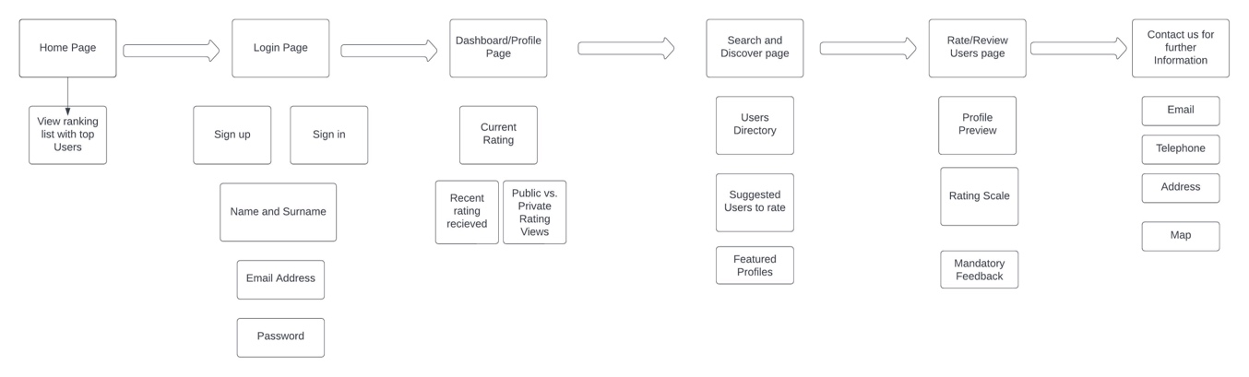

From this I prioritised the features that were most important, these are highlighted in grey.

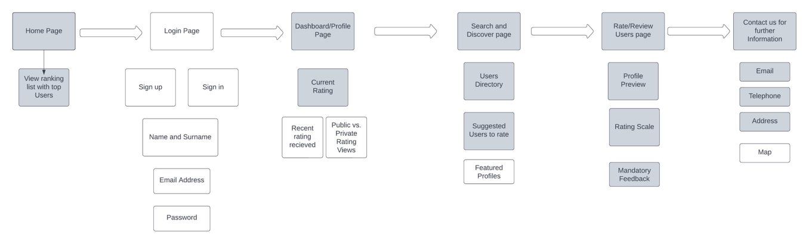

As a minimum viable product (MVP), I aim to produce a web application that allows users to be able to rate other users using 5-star metric system based on reviews.

**MAIN MVPS**

**Homepage:**

The Homepage offers users a glimpse of the dynamic social environment the web application is fostering. Users will immediately encounter a ranking list that highlights top users based on the 5-star grading system. Visitors can navigate through this page and get a sense of the platform's ethos.

**Dashboard/Profile Page:**

The Dashboard/Profile Page acts as a hub for all user-specific interactions. Here a user can view their current rating, any recent feedback they have received, and adjust settings to determine if their rating is publicly viewable or private. The platform encourages genuine interaction and as such the profile highlights only the most crucial information like names and the ratings received.

**Search and Discover Page:**

The Search and Discover Page aids users in finding and interacting with new profiles facilitated by features like the User Directory, Suggested Users to rate, and Featured Profiles.

**Rate/Review Users Page:**

The Rate/Review Users Page is where the main interaction happens. Users can preview profiles; users can use a rating scale to judge their peers and provide mandatory feedback. This feedback loop not only keeps the rating system transparent but also provides invaluable insights to users about out how they are perceived.

**Contact Page:**

Users can contact me via the details given on the page. As a minimum I will include email, telephone, and an address.

**ADDITIONAL FEATURES**

if the initial MVP for this page is met, I will aim to develop the login system that requires the user to enter their university credentials so that I can verify them. This will help avoid discriminatory reviews being left by the user. Having verified users also protects the integrity of the site and information submitted.

# PLANNING

## 2.1 Approach

My intention is to meet my supervisor on a weekly basis, this would give me time to work on my tasks and the meetings would be an opportunity for troubleshooting and to review if my current plan is working or if any changes needed to be made.

## 2.2 Agile Development Techniques

I looked at agile development techniques to help me plan how I would work on this project. I decided that Kanban’s and Test-driven development (TDD) were important for me to achieve my end goal. Using a Kanban would allow me to visualise how much progress I was making and keep track of work that needs to be done.

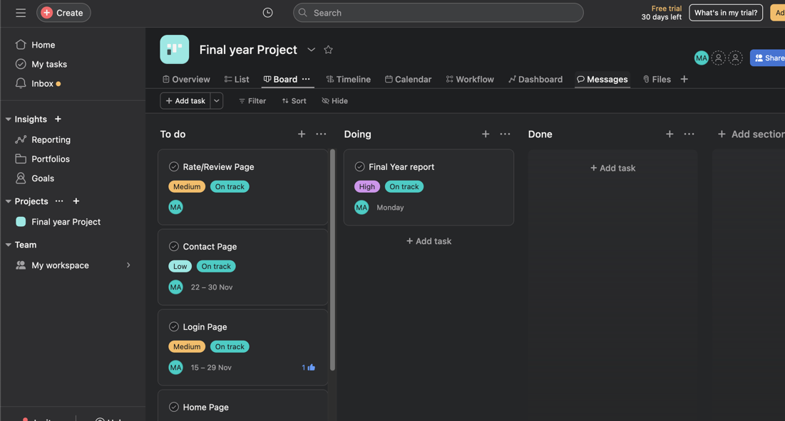

I created a first Kanban using a platform called Asana. Here, I can set deadlines for individual tasks, set follow-ups task and much more.

Test driven development will be an important part of my development, used regularly to measure my progress and functionality of the web application. For each stage of the TDD I would need to write some tests that I expect to fail, run the tests against my software and refactor the code accordingly.

I will also use User-feedback as part of my testing as I want to ensure the user requirements are being met and that I am working in line with the proposal.

## 2.3 Technologies Used

I am using GitHub for version control. I created a repository and uploaded the iterations of my MVPS here.

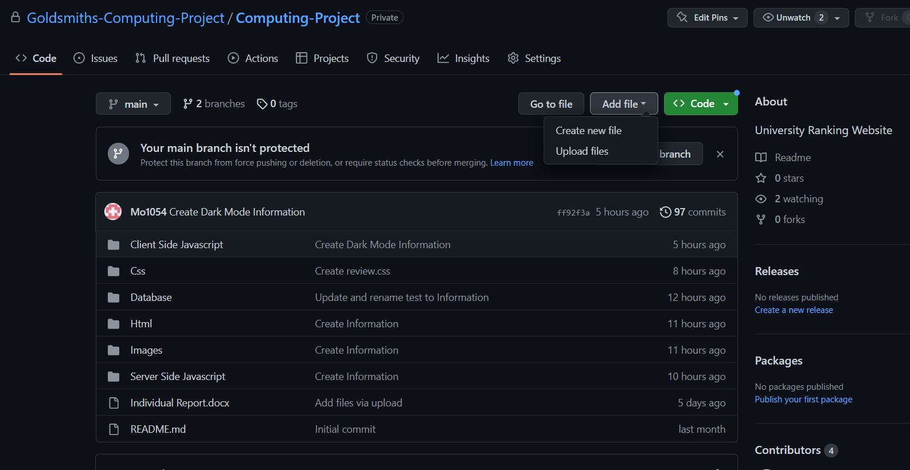

## 2.4 High level project plan

Since this project makes use of the agile method, some tasks are fully extended to the very end of the testing phase. This Gantt chart indicates the constant improvement and refinements of its features and UI.

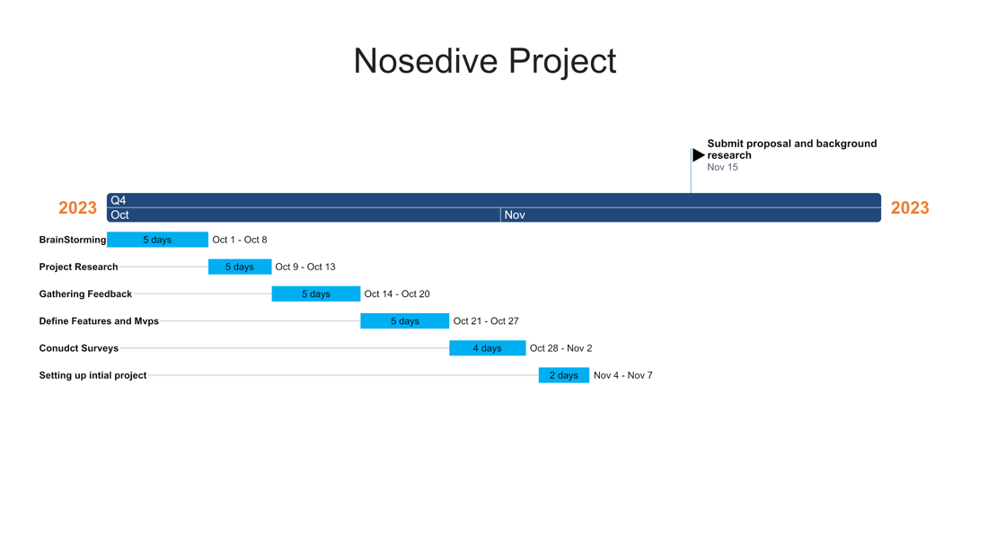

# RESEARCH & ANALYSIS PLANNING

## 3.1 Early Assumption Testing

The early assumption testing for the web application is critical to validate the idea that users desire a more a quantifiable and open way to understand the social credibility of other users. I will begin with the idea that a user's online interaction can be reliably quantified into a rating that can accurately reflect their social behaviour and reputation. To test this, I will conduct surveys and interviews with potential users to measure their perception of such a system and their willingness to participate in the importance they place on others' opinions in online digital interactions.

## 3.2 Market Analysis

**Justification of the Project**

Currently, the social media market has many competitors with their own applications ranging from broad web networks like Facebook and Twitter to smaller communities focused on specific interests like Discord for gaming and 4chan for political issues. I would say that the drastic changes to these platforms also created some challenges. These challenges are the nature of user interaction and the nature of the feedback systems in place.

These traditional social media platforms rely primarily on basic metrics like likes, shares and follower counts to measure engagement. The metrics are useful for measuring user engagement but often provide little insight into the quality and depth of user engagement. Many of these platforms do not handle anonymity that well, leading to issues like trolling and lack of accountability among users.

**Inspiration**

**Online Reputation Management (ORM) Systems**: ORM systems in e-commerce provide a framework for understanding how ratings and reviews can influence user perception (Dellarocas, 2003).

**Peer Review Systems in Academia**: The peer review process, though not without its flaws, offers insights into structured feedback and ranking mechanisms (Bornmann & Daniel, 2008).

**Gamification in social media**: The concept of incorporating game-like elements into non-game contexts (e.g., user rankings) can increase user engagement and motivation (Deterding et al., 2011).

**Black mirror:** The popular television programme black mirror was a primary inspiration. Nosedive, created by Joe wright details the corruption of society caused by social media applications. Nosedive, being the primary web application that allows users to rate each other on a 5-star metric system.

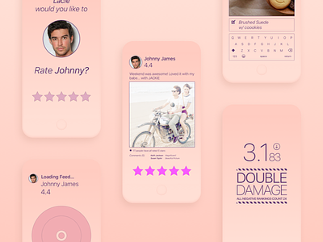

**Past and Current Research**

**Social Media Interaction Models**: Traditional models of social media engagement are limited in their ability to convey the complexities of user interactions (Boyd & Ellison, 2007). These models lack mechanisms for accurately reflecting users' social credibility and the quality of interactions.

**User Feedback and Online Reputation Systems**: Research in online reputation systems, like those implemented in e-commerce sites (e.g., eBay, Amazon), shows the potential of user feedback in building trust and credibility (Resnick et al., 2006). Applying these principles to social media can pioneer a new approach to understanding social dynamics.

**Psychological Impact of social media**: Studies have shown that social media can significantly influence users' self-esteem and social behaviour, often driven by the need for social validation (Nadkarni & Hofmann, 2012).

**Limitations of Existing Work**

**Limitations of Current Social Media Models**: While traditional social media platforms are effective for broad networking, they often fall short in fostering deeper, more meaningful interactions (Ellison et al., 2007). Additionally, issues like anonymity lead to challenges like trolling and lack of accountability.

**Contradictions in User Feedback Systems**: Although user feedback can build trust, it can also lead to biases and unfair characterizations, especially in the absence of robust verification mechanisms (Tadelis, 2016).

**Developing Areas**: Incorporating psychological and sociological insights into social media design is an emerging field, offering opportunities to create more empathetic and socially responsible platforms (Valkenburg & Peter, 2013).

**Dead Ends**: Over-reliance on quantitative metrics (like number of likes or followers) has been criticized for oversimplifying complex social interactions (Postigo, 2016).

**Similar Projects**

Projects like LinkedIn's endorsement system or academic peer-review platforms provide valuable lessons. However, these systems often lack transparency and can be influenced by social biases (Gilbert et al., 2018).

**Contextual Placement within the Field**

The project I am developing aligns itself at the intersection of social media, online behaviour and user experience design. It will contribute to the ongoing discourse about the role of social media in shaping online identities and interactions. I have introduced a novel user ranking mechanism. This challenges the conventional engagement metrics and opens avenues for more meaningful online social experiences.

**Potential Algorithms for rating system**

**Weighted Moving Average (WMA) Algorithm:**

* Ratings are not treated equally. More recent ratings have a higher weight than older ones.
* Helps in evolving the user's score dynamically with time.
* Formula: WMA=∑i=1nwi×xi∑i=1nwiWMA=∑i=1n wi ∑i=1n wi ×xi
* Where w is the weight and xi is the rating

Sukparungsee, S., Areepong, Y., & Taboran, R. (2020)

**Elo Rating System:**

* Originally developed for chess, this system adjusts ratings based on the difference between expected and received scores.
* Good for pairwise comparison if your system involves one user rating another directly.
* The difference in ratings between two users serves as a predictor for the outcome of a rating.

Zanco, D. G. de P., Szczecinski, L., Kuhn, E. V., & Seara, R. (Year not specified)

**Bayesian Average:**

* Used to avoid extreme ratings when there's insufficient data.
* It considers the global average rating and the number of ratings a user has.
* Good for startups or new users with few ratings

Yang, X., & Zhang, Z. (2013)

## 3.4 Methodology

One of the research development tools I used to develop a better understanding of the LinkedIn recommendation system was a market survey. This will help me better develop the features on my own project.

**Questions:**

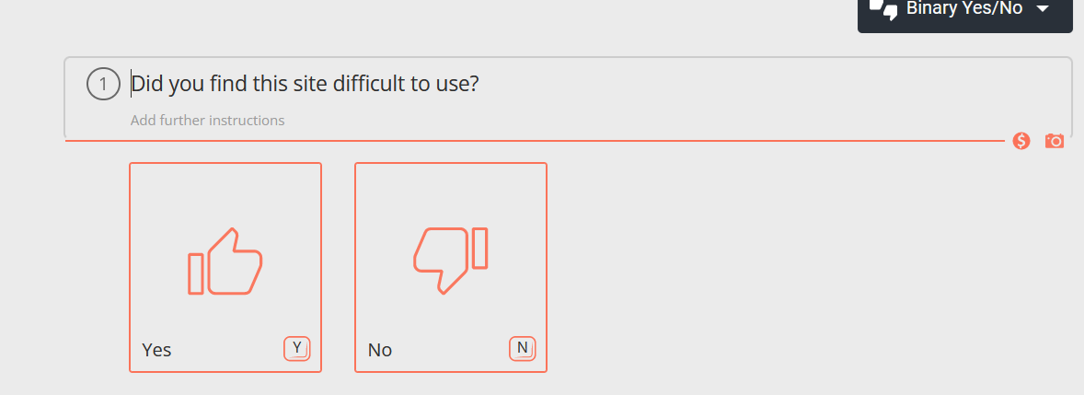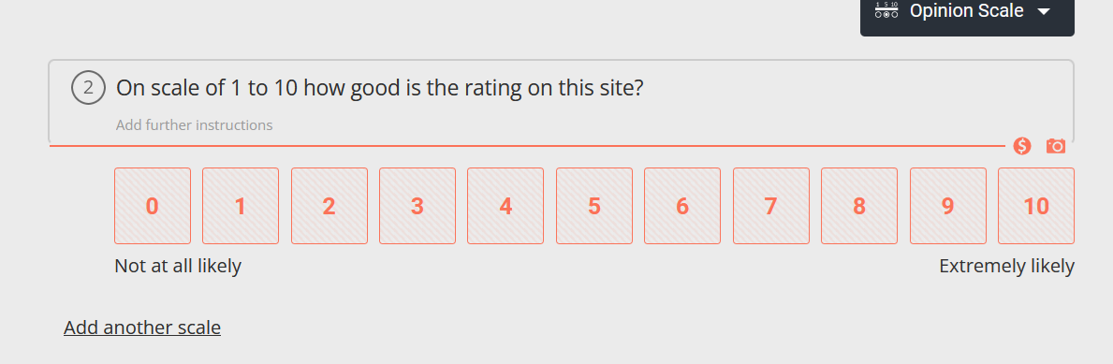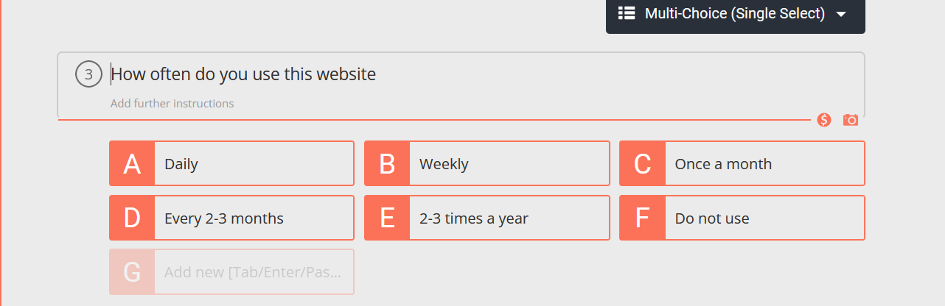

**Result:**

## 3.4 Design Heuristics

When thinking about design heuristics I wanted to make sure that my web application met the following criteria by achieving the following targets below. By using design heuristics, I can approach problems in a systematic way and generate solutions that are more likely to meet the needs of users and stakeholders. This should result in a better design outcome.

Simplicity

I want to keep the design of my web application simple, so that it is more accessible and easier to understand and navigate for the user.

Feedback

The design should provide clear feedback to the users, to help them understand the impact of their actions whilst navigating the site and how the system works.

Affordances

I want to ensure that the interface is clear and intuitive to the user.

Consistency

This is an important aspect of our design, it needs to be consistent in its colours, typography, and layout, to create a unified and cohesive visual expression.

Error prevention

I want my design to guide users towards correct actions and prevent mistakes, this ties in with the simplicity; having an easy to navigate system will help prevent errors by the user.

## 3.5 Stakeholder Analysis

I initially identified the main stakeholders to be the public businesses and Service Providers and Government and Regulatory Bodies.

**Users**: The primary stakeholders. Their social status is dictated by their ratings on the app. This includes every individual in society who engages with the app for social standing and opportunities.

**Businesses and Service Providers**: Businesses that could use the app's rating system to determine the eligibility of customers for services or discounts. The business operations and customer relations are significantly influenced by the app.

**Government and Regulatory Bodies**: The government could use the app as a tool for social control. They could impose regulation, impacting policies and legal frameworks.

# APPLICATION REQUIREMENTS

## 4.1 Functional Requirements

**User Ranking System:** A core feature where users can rate others using a 5-star system based on their interactions. Using NoSQL's flexible schema for storing and retrieving user ratings and reviews and implement algorithms in JavaScript for the 5-star rating system.

**User Authentication:** The users must log in with university credentials to ensure accountability and prevent anonymous reviews. I will develop authentication processes using Node.js with university credentials for secure logins.

**User Profile Management: T**heusers be able to create, edit, and view their profiles. This is including their ratings and feedback received. Use NoSQL databases to store user profile information, allowing for flexible data models as the data grows.

**Search and Discovery:** Users should be able to search for other users, view suggested profiles and explore featured profiles.

**Rating and Review System:** Users can rate others and leave feedback. I will design the backend logic in Node.js for users to rate and review others then store this data in the NoSQL database

**Contact system:** The users need a way to contact support. This will be through the contact page. I will create a contact form feature using JavaScript and Node.js, with entries stored in NoSQL

### 4.1.1 System Requirements

**Compatibility:** Ensure the application is compatible across different browsers and devices. Focusing on responsive design with JavaScript.

**Scalability:** Use Node.js and NoSQL databases like MongoDB for their scalability in turn handling an increasing load with efficient data handling and retrieval.

**Security:** Implement robust security measures in Node.js in turn safeguarding user data, especially with the use of university credentials.

**Performance:** I will optimize JavaScript and Node.js code for fast response times, ensuring efficient server-side processing.

**Data Storage:** Using a NoSQL database for flexible and scalable data storage.

### 4.1.2 User Requirements

**Ease of Use:** The JavaScript on the front end will be designed to be user-friendly. This will ensure the user interface is seamless and versatile.

**Accessibility:** I will make sure to adhere to the web accessibility standards in my JavaScript frontend development.

**Feedback System:** I will use JavaScript to provide clear feedback to users on my web application.

**Privacy Controls:** I will implement privacy settings in the application, allowing users to control their data visibility, managed through Node.js and stored in NoSQL.

**Reliability:** I will ensure the backend processes in Node.js are very robust and error-free for reliable application performance and in turn this will help combat latency issues with the users on my web application.

## 4.2 Non-functional Requirements

**Usability:** I will create a user-friendly interface with JavaScript, prioritizing ease of navigation and clarity.

**Performance Efficiency:** Optimize Node.js server-side operations and JavaScript execution for efficient application performance.

**Maintainability:** Write clean, modular, and well-documented code in Node.js and JavaScript, ensuring easy maintenance and updates.

**Security:** I will implement comprehensive security measures in both Node.js server-side logic and JavaScript frontend, safeguarding against vulnerabilities.

**Accessibility**: As stated previously, the site should be accessible to users with disabilities, adhering to WCAG.

**Compliance:** The site should comply with the relevant laws and regulations relating to privacy, data protection and security. Inappropriate and offensive content will be filtered.

# Resources

1. Boyd, D. M., & Ellison, N. B. (2007). Social network sites: Definition, history, and scholarship. *Journal of Computer‐Mediated Communication*, 13(1), 210-230. [Accessed 29 Oct. 2023]
2. Dellarocas, C. (2003). The digitization of word of mouth: Promise and challenges of online feedback mechanisms. *Management Science*, 49(10), 1407-1424. [Accessed 21 Oct. 2023]
3. Deterding, S., Dixon, D., Khaled, R., & Nacke, L. (2011). From game design elements to gamefulness: defining "gamification". *Proceedings of the 15th International Academic MindTrek Conference*. [Accessed 31 Oct. 2023]
4. Gilbert, E., et al. (2018). I rate you. You rate me. Should we do so publicly?. *Journal of* *Social Media Studies*, 5(1), 15-29. [Accessed 29 Oct. 2023]
5. Kaplan, A. M., & Haenlein, M. (2010). Users of the world, unite! The challenges and opportunities of Social Media. *Business Horizons*, 53(1), 59-68. [Accessed 29 Oct. 2023]
6. Nadkarni, A., & Hofmann, S. G. (2012). Why do people use Facebook?. *Personality and Individual Differences*, 52(3), 243-249. [Accessed 29 Oct. 2023]
7. Postigo, H. (2016). The socio-technical architecture of digital labor: Converting play into YouTube money. *New Media & Society*, 18(2), 332-349. [Accessed 29 Oct. 2023]
8. Resnick, P., et al. (2006). The value of reputation on eBay: A controlled experiment. *Experimental Economics*, 9(2), 79-101. [Accessed 21 Oct. 2023]
9. Tadelis, S. (2016). Reputation and feedback systems in online platform markets. *Annual Review of Economics*, 8, 321-340. [Accessed 15 Oct. 2023]
10. Valkenburg, P. M., & Peter, J. (2013). The differential susceptibility to media effects model. *Journal of Communication*, 63(2), 221-243. [Accessed 25 Oct. 2023]
11. Hazelkorn, Ellen (2019) University Rankings: there is room for error and "malpractice". [Online]
12. Vu, K.P.L., Proctor, R.W. and Hung, Y.H., 2021. Website design and evaluation. Handbook of human factors and ergonomics, pp.1016-1036.
13. Guide.freecodecamp.org. (2019). Advantages and Disadvantages of JavaScript. [online] Available at: <https://guide.freecodecamp.org/javascript/advantages-and-disadvantages-of-javascript/> [Accessed 3 Apr. 2023].
14. Redbytes: Custom Mobile Application Development Company [iOS, Android, Windows]. (2019). 15 Best Programming Languages For Mobile Apps 2019 | Redbytes. [online] Available at: <https://www.redbytes.in/best-programming-language-for-mobile-apps/> [Accessed 28 Oct. 2023].
15. Spencer, J. (2019). Top 9 Advantages of JavaScript. [online] MarkupBox. Available at: <https://www.markupbox.com/blog/advantages-of-javascript/> [Accessed 22 Oct. 2023]
16. Kathy lund Dean (2014), It’s not just Rate My Professor anymore! Ethical issues with student evaluations of teaching [online], Available at <https://connect.aom.org/blogs/kathy-lund-dean/2014/01/21/its-not-just-rate-my-professor-anymore-ethical-issues-with-student-evaluations-of-teaching-set> [Accessed 20 Oct. 2023]
17. Webaccess.berkeley.edu. (2019). Top 10 Tips for Making Your Website Accessible | Web Access. [online] Available at: <https://webaccess.berkeley.edu/resources/tips/web-accessibility> [Accessed 31 Oct. 2023].
18. Bcs.org. (2019). [online] Available at: <https://www.bcs.org/membership/become-a-member/bcs-code-of-conduct/> [Accessed 26 Oct. 2023]
19. Lee, J. and Shin, D. (2018). Understanding and preventing academic plagiarism: A critical review. Journal of Hospitality, Leisure, Sport & Tourism Education, 23, pp.47-54.
20. Bickford, D. J., & Wright, S. J. (2019). Examining the Impact of Instructional Design and Course Content Delivery on Student Success in Online and Blended Environments. Journal of Educational Technology Development and Exchange, 12(1), 1-18.
21. Schneier, B. (2019). The Internet of Things Will Turn Large-Scale Hacks into Real World Disasters. [online] Available at: <https://www.theatlantic.com/technology/archive/2014/01/the-internet-of-things-will-turn-large-scale-hacks-into-real-world-disasters/282860/> [Accessed 29 Oct. 2023]
22. Michalopoulos, M., & Triantafillidou, A. (2019). A survey of cyber security risks in cloud computing. Journal of Network and Computer Applications, 127, 1-25. [Accessed 27 Oct. 2023]
23. Tinto, V. (2017). From Theory to Action: Exploring the Institutional Conditions for Improving Student Retention. In Student Success in College (pp. 63-84). Routledge. [Accessed 25 Oct. 2023
24. Van Dusen, D. S. (2022). Measuring Student Engagement and Retention in Online Learning. Online Learning Journal, 26(1), 106-127. [Accessed 1 Apr. 2023]
25. Hass, R. W., & Daugherty, M. K. (2022). Cybersecurity in higher education: A multi-method examination of students' security behaviours. Computers & Security, 119, 102277. [Accessed 30 Oct. 2023]
26. O'Neill, D. K., & Saipe, D. (2022). A framework for student-centred online learning: A case study in graduate educational leadership. Journal of Education and Learning, 11(1), 1-16. [Accessed 29 Oct. 2023]
27. Sukparungsee, S., Areepong, Y., & Taboran, R. (2020). Exponentially weighted moving average—Moving average charts for monitoring the process mean. PLoS ONE, 15(2), e0228208. [Accessed 13 Nov. 2023].
28. Zanco, D. G. de P., Szczecinski, L., Kuhn, E. V., & Seara, R. (Year not specified). A comprehensive analysis of the Elo rating algorithm: Stochastic model, convergence characteristics, design guidelines, and experimental results. [Accessed 13 Nov. 2023].
29. Yang, X., & Zhang, Z. (2013). Combining prestige and relevance ranking for personalized recommendation. Proceedings of the 22nd ACM International Conference on Information & Knowledge Management - CIKM '13, 1877–1880. [Accessed 13 Nov. 2023].